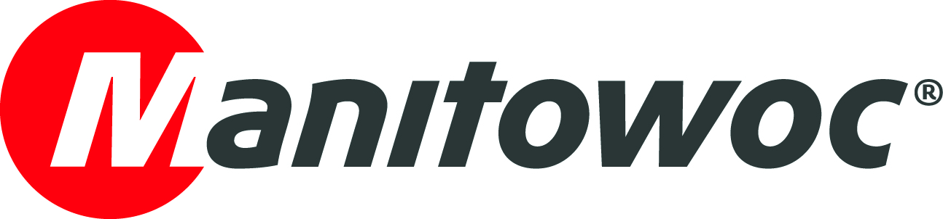
CAPTION RELEASE

April 23, 2019

Valente recognized for purchasing the most GMEs in Europe and Africa in 2018

Manitowoc has recognized long-term Potain partner Valente for having purchased the most GME tower cranes in Europe and Africa in 2018.

During a special ceremony at bauma 2019, Valente was presented with an award by Orlando Mota, vice president of sales for Europe and Africa at Manitowoc.

Established in 1979, Valente is a leading tower crane sales and rental company based in Belley, near Lyon. The company has represented Potain since 1996 and supplies cranes to customers across the Rhône Alpes region.

-END-

CONTACT
Cristelle Lacourt
Manitowoc
T +33 472 182 018
cristelle.lacourt@manitowoc.com

ABOUT THE MANITOWOC COMPANY, INC.
Founded in 1902, The Manitowoc Company, Inc. is a leading global manufacturer of cranes and lifting solutions with manufacturing, distribution, and service facilities in 20 countries. In the United States, the Grove, Manitowoc, National Crane, Potain and Shuttlelift brands are sold and serviced by Grove US, LLC, a wholly owned subsidiary of The Manitowoc Company, Inc. In 2018, Manitowoc’s net sales totaled $1.8 billion, with over half generated outside the United States.

THE MANITOWOC COMPANY, INC.
One Park Plaza – 11270 West Park Place – Suite 1000 – Milwaukee, WI 53224, USA
T +1 920 684 4410
www.manitowoc.com

